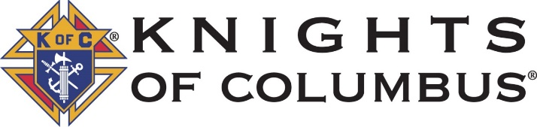

Pendleton Council 1673

2021 Scholarship Program
(Applicants Currently in College)

Eligibility:
Applicants must be:
▪ Currently enrolled full time (at least 12 credit hours) in a generally accredited two- year or four-year college or university with enrollment continuing into 2021-2022.
▪ An active member (or the son/daughter of an active member) of one of the following parishes: St. Andrew (Mission); St. Helen (Pilot Rock); St. Mary (Pendleton); St. Patrick (Heppner); Sacred Heart (Athena); St. William (Ione).

Students previously awarded a Knights of Columbus Scholarship from Pendleton Council 1673 are not eligible to receive a scholarship in consecutive years. They may again apply after waiting one year. Applicants may only receive one college scholarship while pursuing an undergraduate degree.

Application Procedures:

Interested students must apply by completing the attached application form. The completed application form must be returned to the Knights of Columbus no later than post marked April 15, 2021. Mail applications to: Knights of Columbus Scholarship, Attn. Mike Townsend, 46622 Kirkpatrick Road, Pendleton OR 97801. Questions: Contact Mike Townsend (541) 274-0765.

Selection Considerations:

- The applicant must demonstrate an ability to perform an acceptable level in an approved college or university through: (1) past academic performance, (2) aptitude test scores, (3) participation in extracurricular/outside activities/employment,
- The applicant must demonstrate a continued commitment to the Catholic faith through participation in church activities such as youth groups, corporal works of mercy, or retreats; volunteer work or other community service.
- Financial need shall be considered, however, it shall not serve as a primary basis for selection.

Amount of Scholarship and Term:

The amount of the scholarship is $500 to be awarded for the period of one academic year only.

Award Notification:
The Knights of Columbus, Pendleton Council 1673 will notify the successful applicant(s) of their decision by May 31, 2021.

